Task on Jenkins-04
1) Setup Jenkins CICD pipeline using freestyle job using Docker containers using below code.
Source Code: https://github.com/betawins/hiring-app.git
Stages:
Started with connecting the instance and then installed the java-21 version.
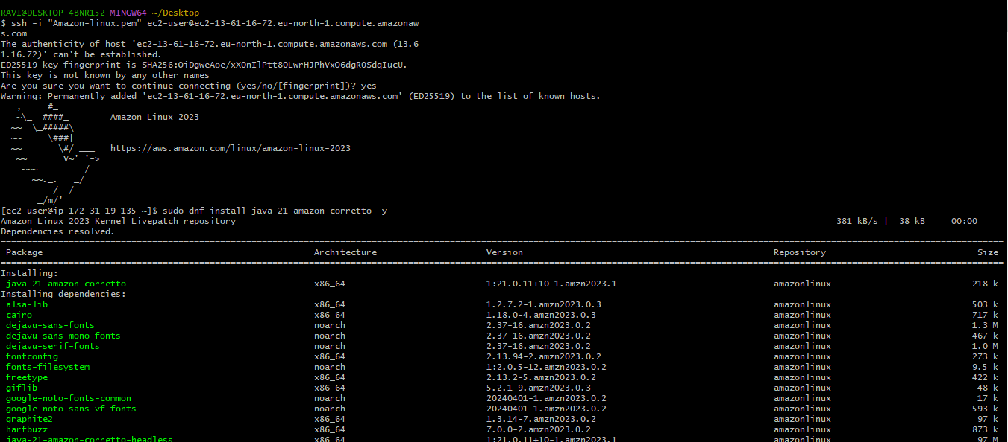
Then installed the Jenkins and Git in the same server:
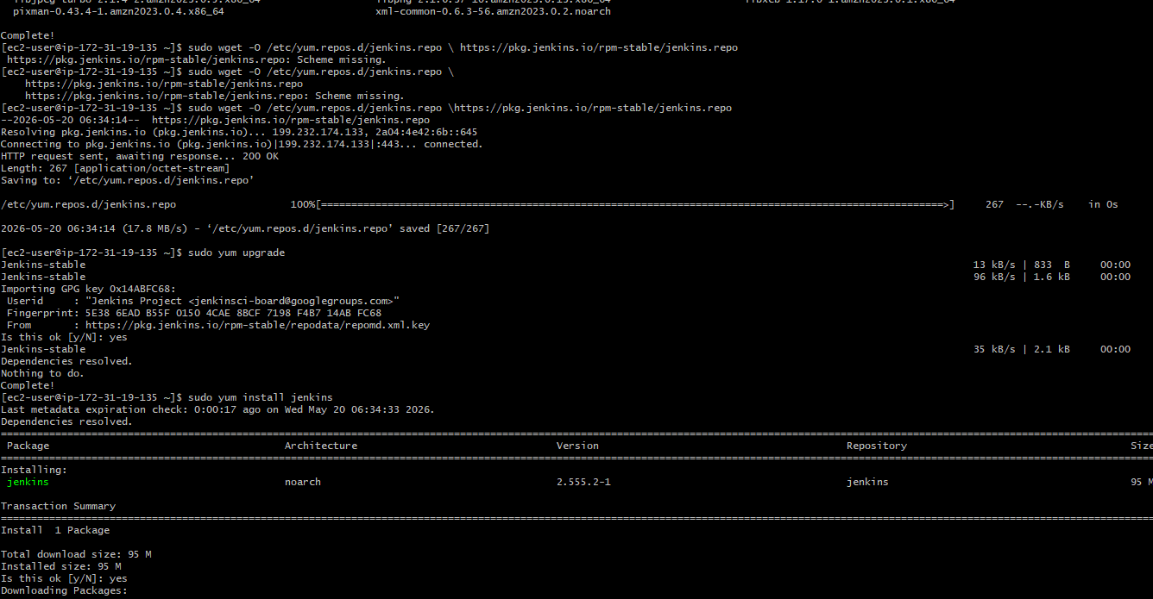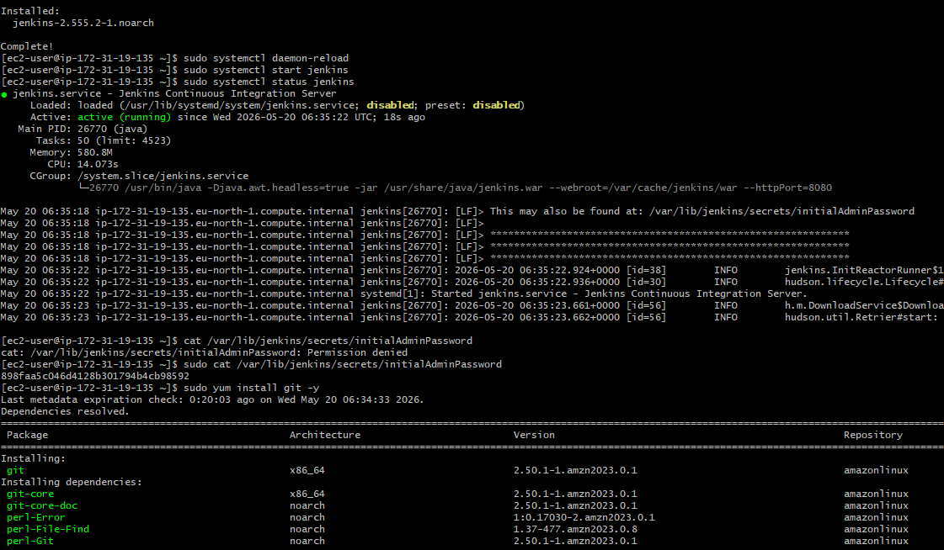
Then installed the sonar scanner which is installed in the same server with the below link:
wget https://binaries.sonarsource.com/Distribution/sonar-scanner-cli/sonar-scanner-cli-3.2.0.1227-linux.zip
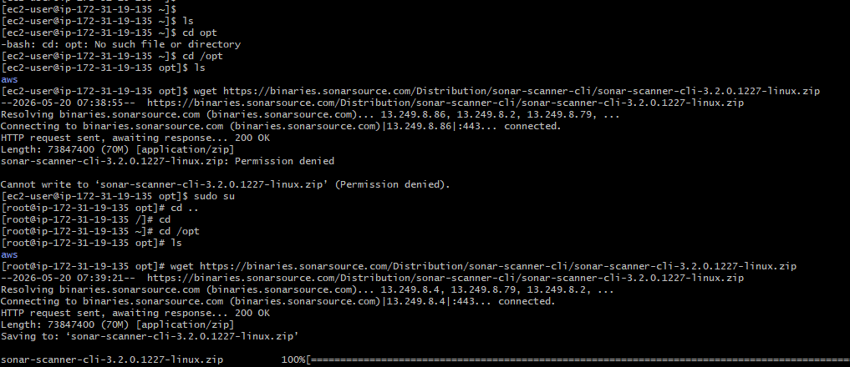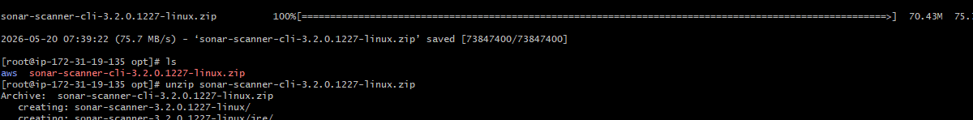
Then installed the maven in the same server
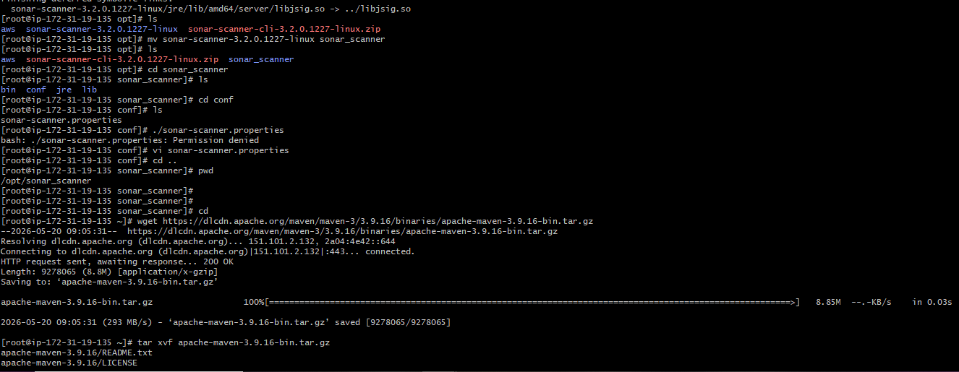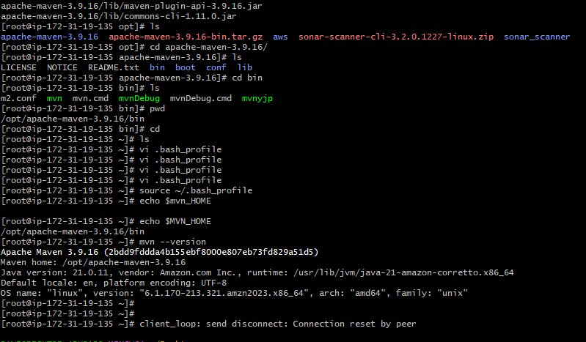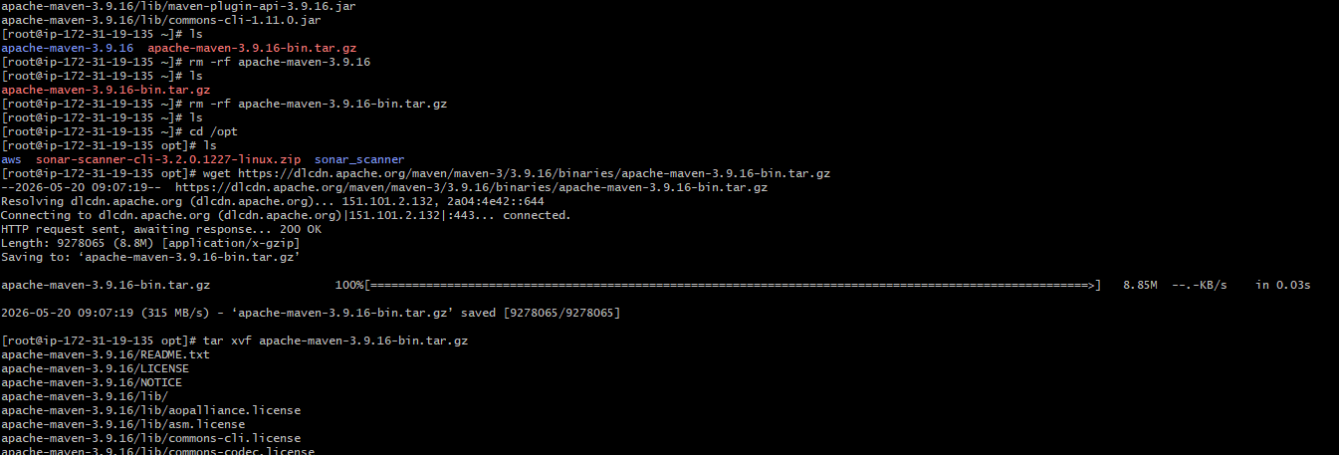
- Git Clone:
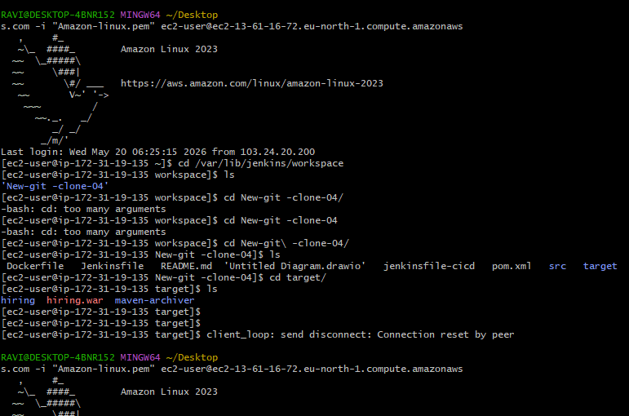
- SonarQube Integration: Started with connecting the instance and then installed the java-1.8* version and also installed the git in it:
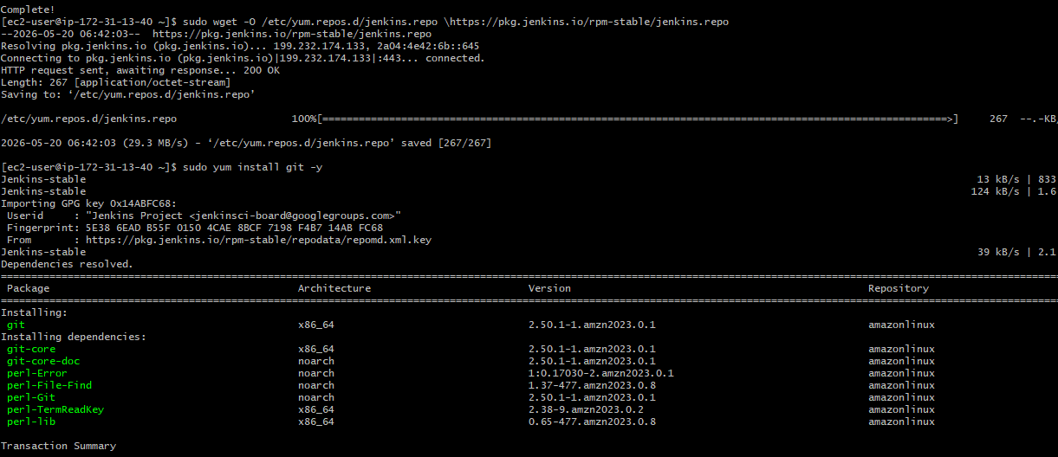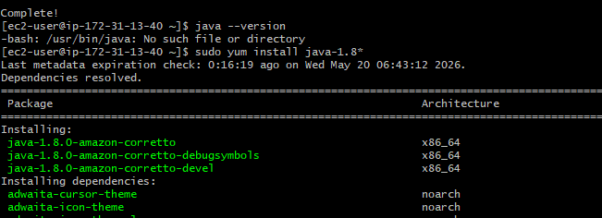
Installed the mysql in the this server with the links shown in the image:
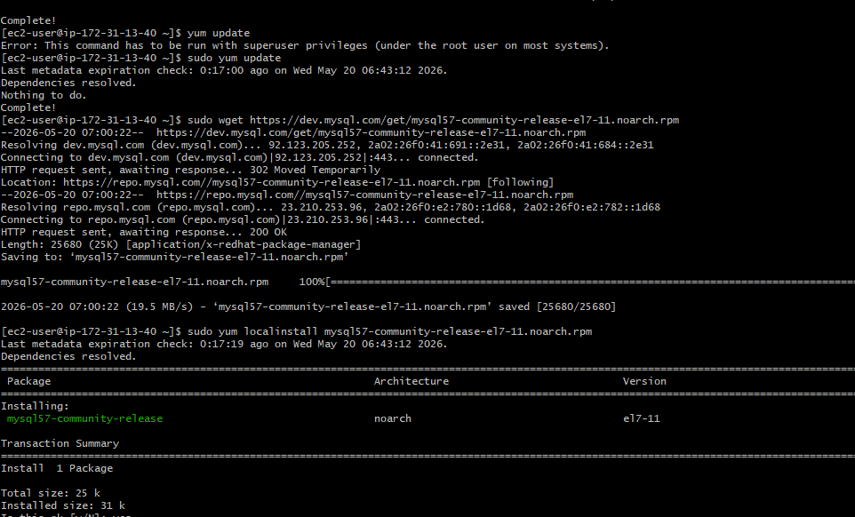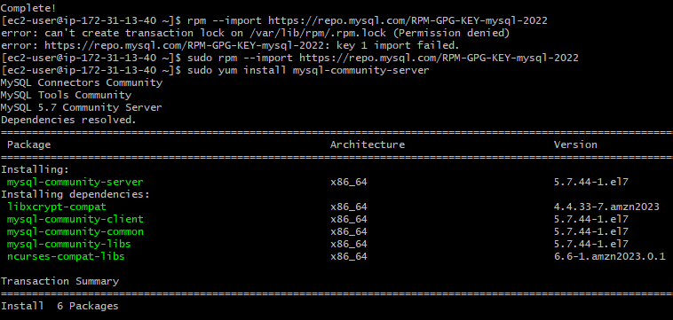
Then installed and connected to the RDS and then created a new user in it:
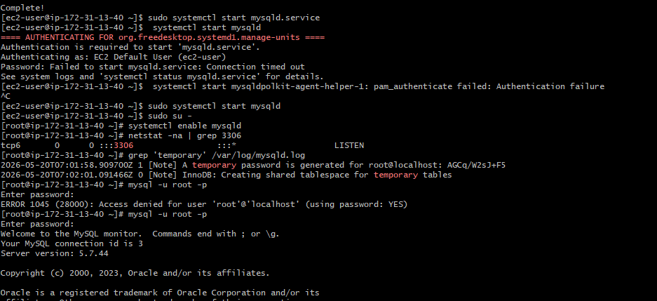
Then installed the SonarQube in this server:
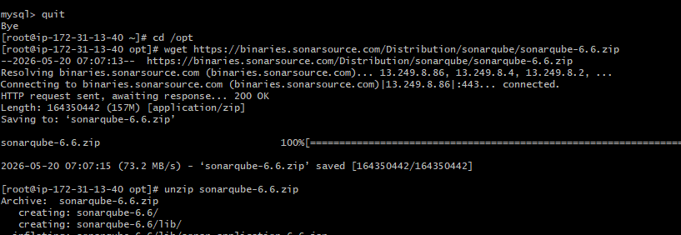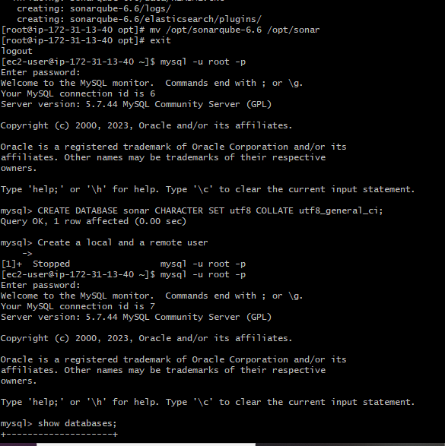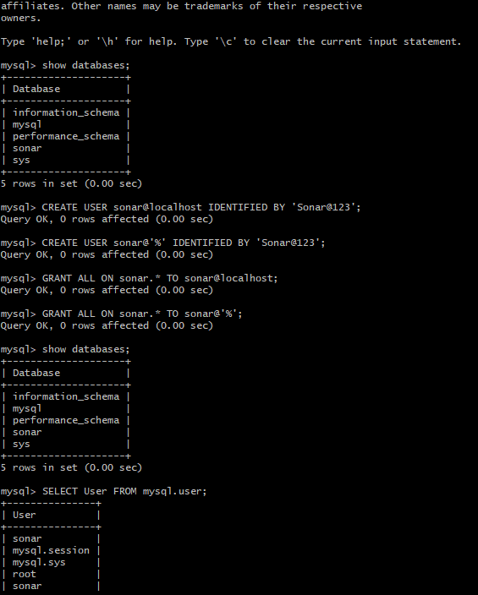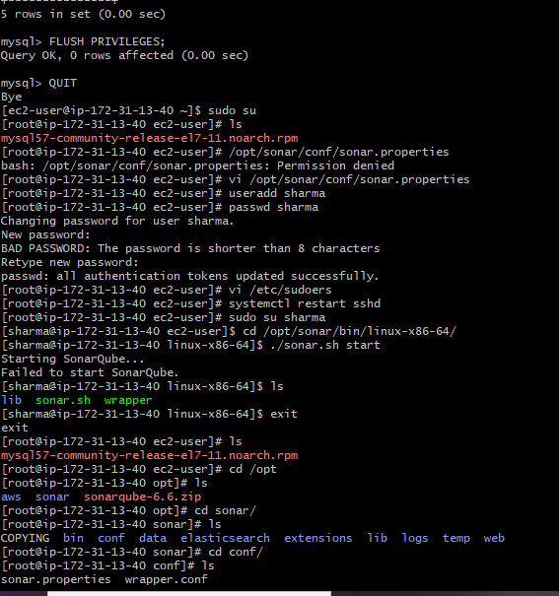
Then follow all the steps show below to start the SonarQube:
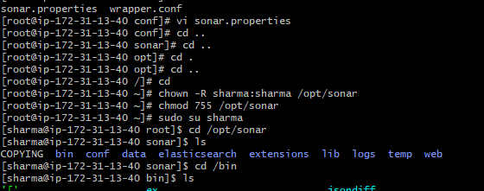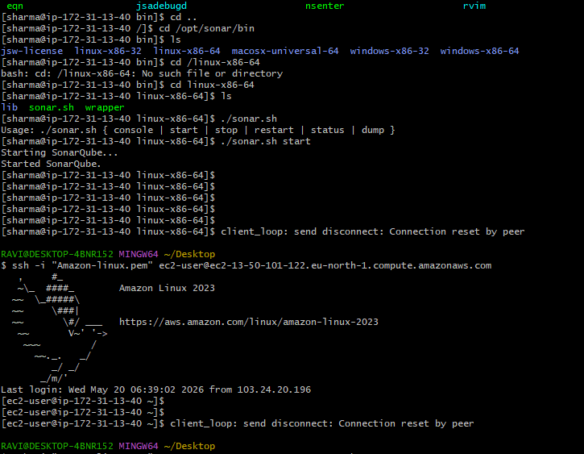
- Maven Compilation
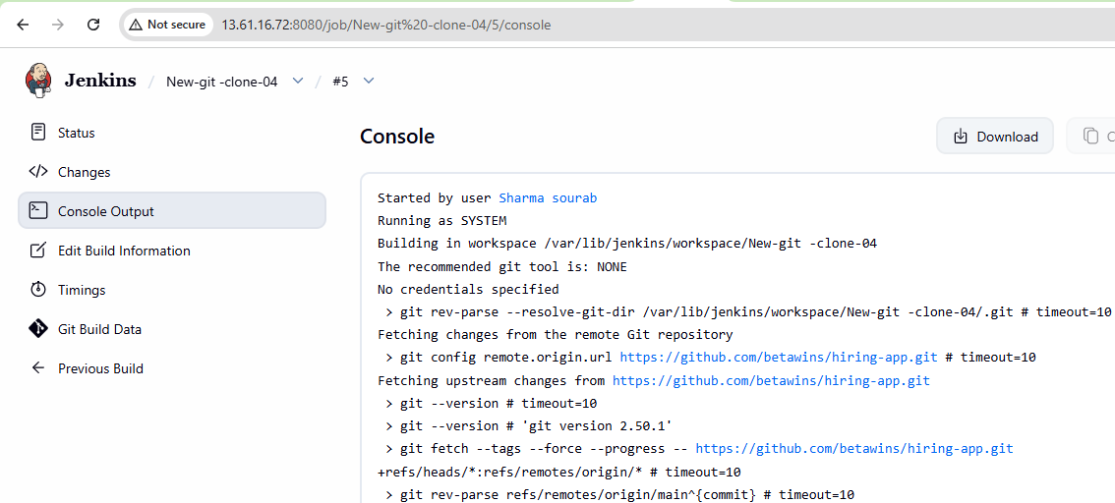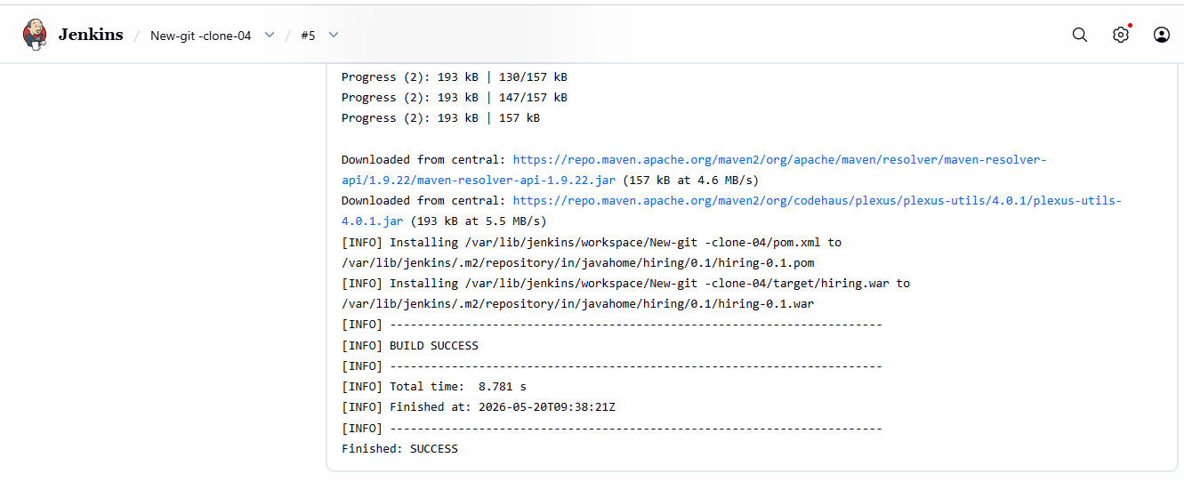
- Nexus Artifactory:
Installed the Java-1.8* version in this instance.
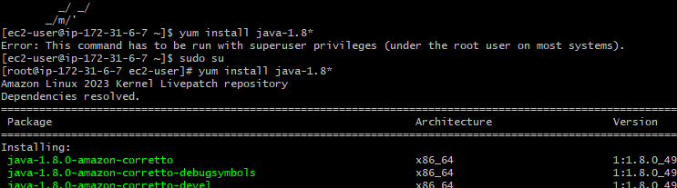
Followed the link to download with the nexus repo in this server:
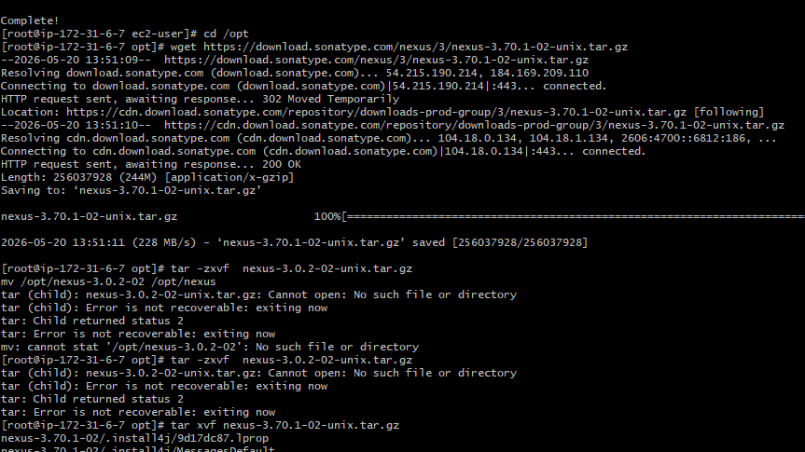
Then created a new user with Sharma and then followed the same steps shown below to make sure the Nexus is up and running:
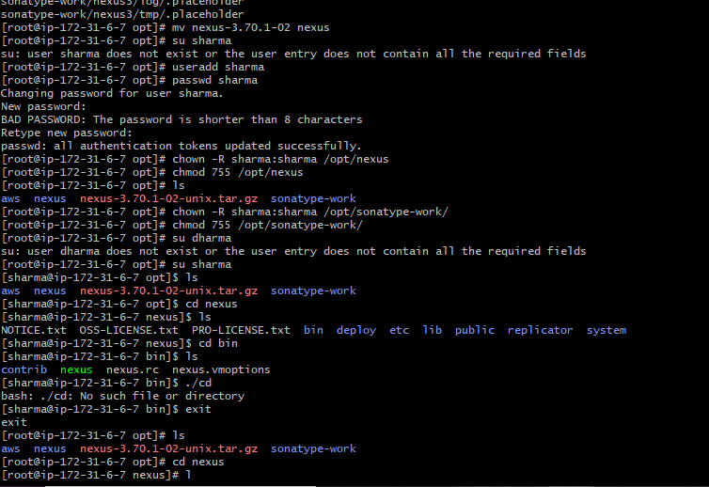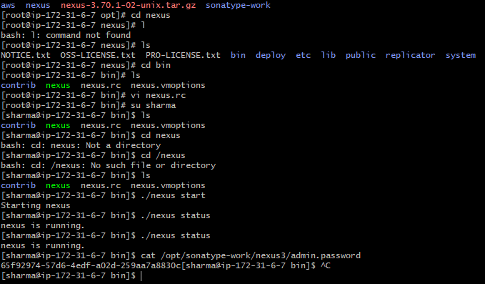
Once this is done then you will be able to access the nexus repo with the public ip in the browser:
Admin-admin
Passwd- sharma
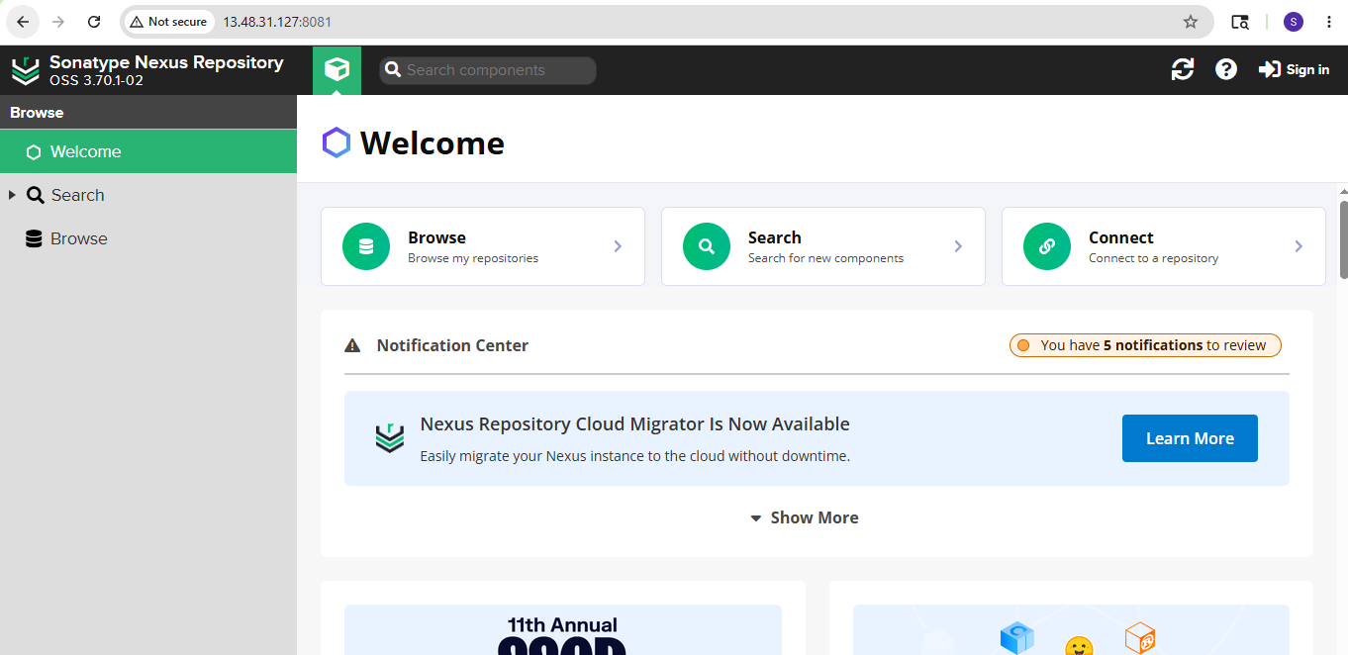
Then click on the Jenkins and then click on build now to check if the configurations are done correctly or not:
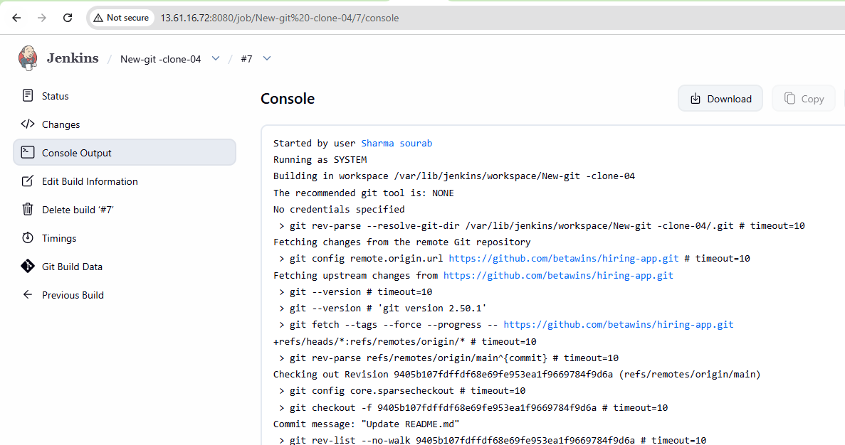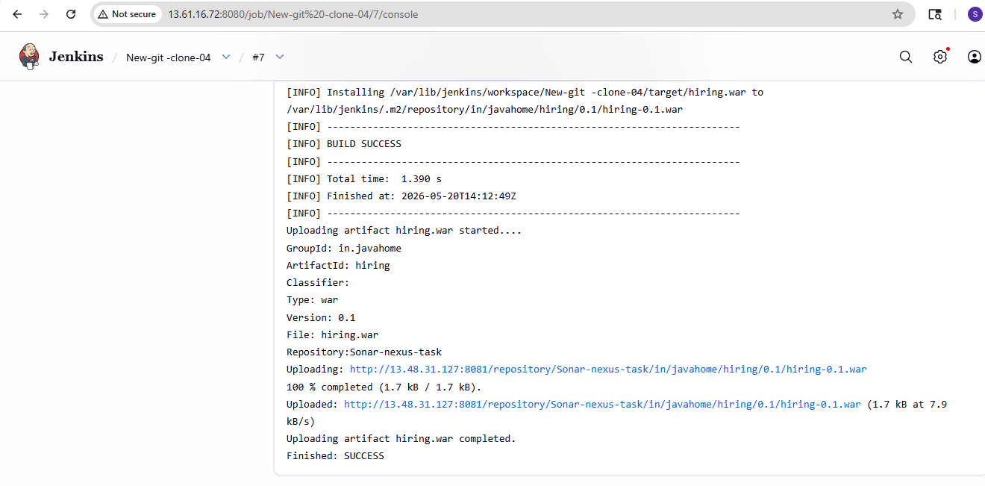
- Slack Notification
- Deploy On tomcat:
Created a new instance and then installed java-17 and Tomcat as well:
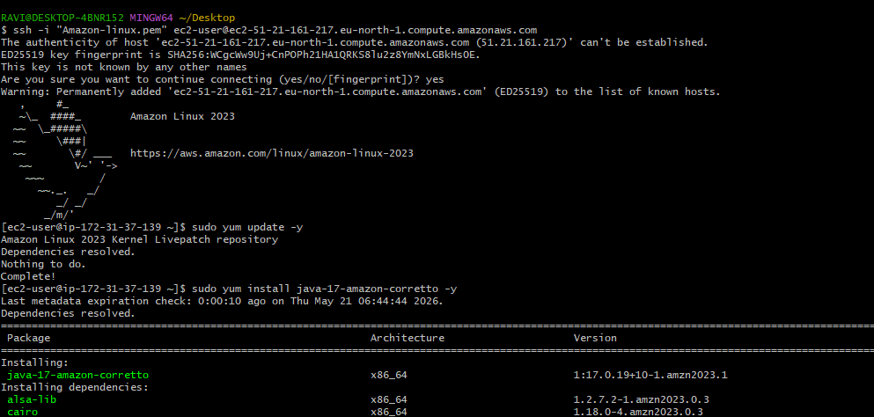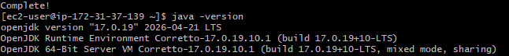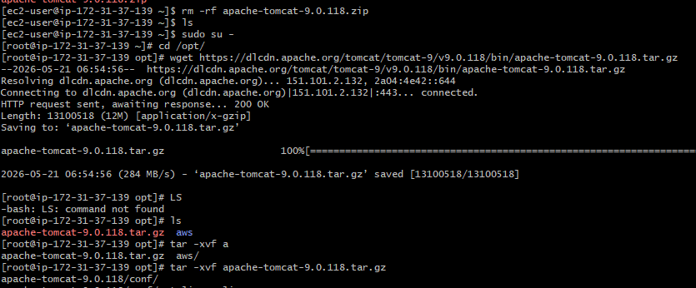
Once the installation is done try to cross check with the browser with the public ip and then with the port number : 8080 as shown below:
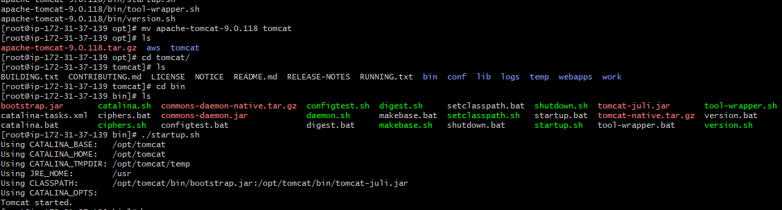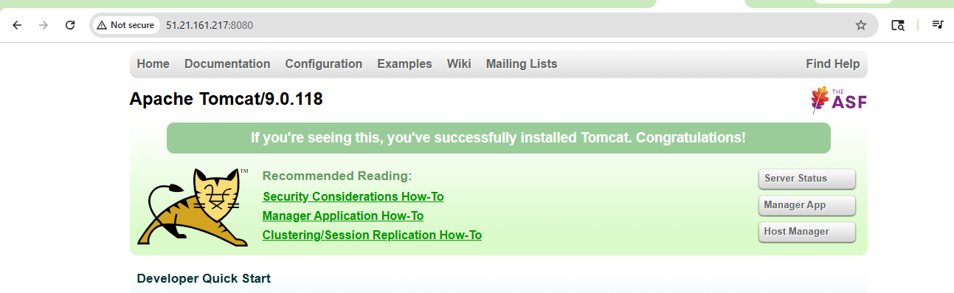
Open this below path and then added the below script in CLI:
vi /opt/tomcat/conf/tomcat-users.xml
<role rolename="manager-gui"/>
<role rolename="manager-script"/>
<role rolename="manager-jmx"/>
<role rolename="manager-status"/>
<user username="admin" password="Admin@123" roles="manager-gui,manager-script,manager-
jmx,manager-status"/>
After this enter this content in the below files:
vi /opt/tomcat/webapps/manager/META-INF/context.xml
vi /opt/tomcat/webapps/host-manager/META-INF/context.xml
Once the above steps are done we are able to login in the tomcat server and then we will be able to deploy the codes now:
Before this we need to make all the servers and the tools like sonar qube, nexus should be up and running:
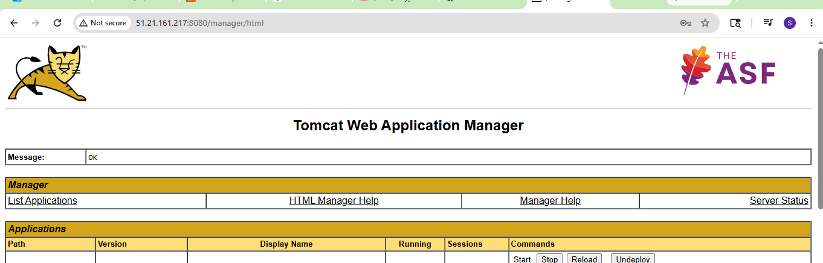
Made the Ip’s change in the manage Jenkins options for SonarQube, nexus, and then clicked on the build now option and then our job triggered completed successfully. :
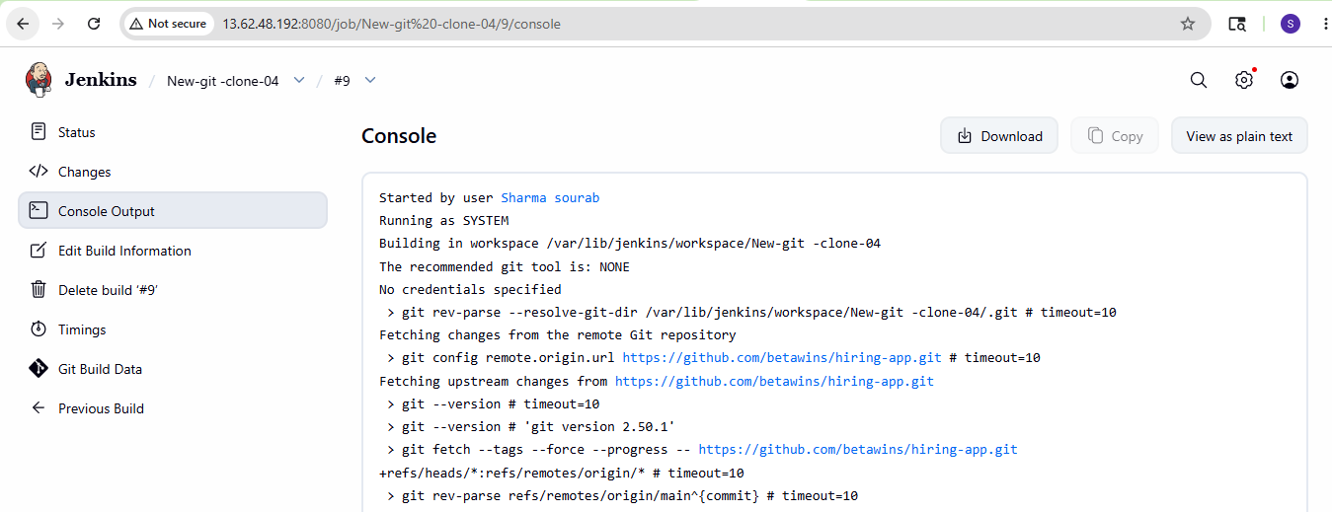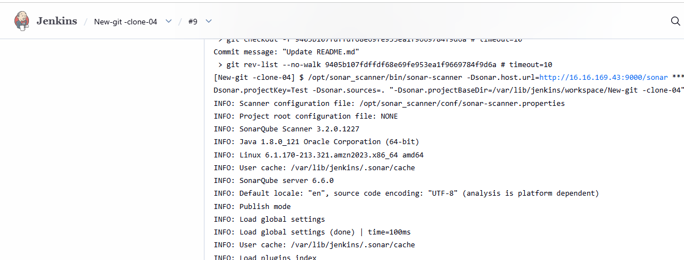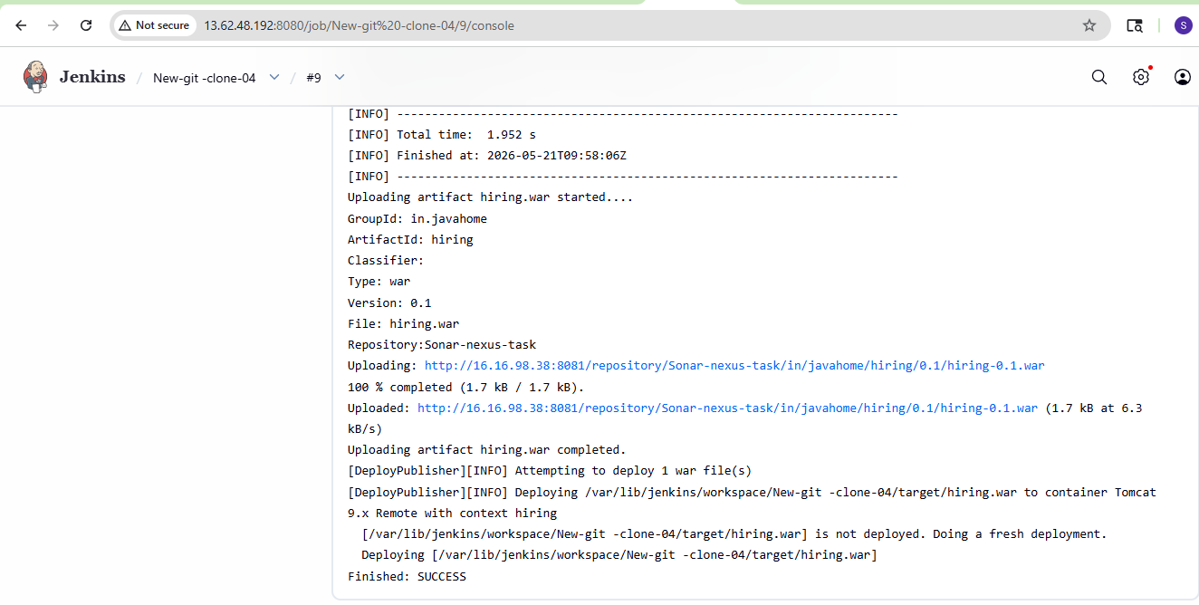
Tomcat server running with adding the hiring Infront of it:
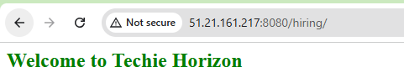
2) Setup a Jenkins CICD pipeline using Declarative pipeline using feature-1.1 branch.
Source Code: https://github.com/betawins/sabear_simplecutomerapp/tree/feature-1.1
stages:
- Git Clone:
- SonarQube Integration: changed the new ips of the instances in the Jenkins server:
- Maven Compilation- changed the new ips of the instances in the Jenkins server:
- Nexus Artifactory: Created a new repo in nexus and configured it with the below script: pipeline {
- agent any
- tools {
- maven 'Maven-home'
- }
- stages {
- stage('Clean Workspace') {
- steps {
- cleanWs()
- }
- }
- stage('Clone Code') {
- steps {
- git branch: 'master',
- url: 'https://github.com/betawins/sabear_simplecutomerapp.git'
- }
- }
- stage('Build using Maven') {
- steps {
- sh 'mvn clean install'
- }
- }
- stage('Check Build Files') {
- steps {
- sh 'ls -ltr target'
- }
- }
- stage('Publish to Nexus') {
- steps {
- script {
- try {
- def artifactPath = sh(
- script: "ls target/*.war | head -1",
- returnStdout: true
- ).trim()
- echo "Uploading Artifact: ${artifactPath}"
- nexusArtifactUploader(
- nexusVersion: 'nexus3',
- protocol: 'http',
- nexusUrl: '13.48.23.20:8081',
- repository: 'sample-app',
- groupId: 'com.javatpoint',
- version: "${BUILD_NUMBER}-SNAPSHOT",
- credentialsId: 'Nexus-task-6000',
- artifacts: [
- [
- artifactId: 'SimpleCustomerApp',
- classifier: '',
- file: artifactPath,
- type: 'war'
- ]
- ]
- )
- } catch (Exception e) {
- error "Failed to upload artifact to Nexus: ${e.message}"
- }
- }
- }
- }
- stage('Deploy On Tomcat') {
- steps {
- script {
- try {
- def warFile = sh(
- script: "ls target/*.war | head -1",
- returnStdout: true
- ).trim()
- echo "Deploying WAR: ${warFile}"
- deploy adapters: [
- tomcat9(
- credentialsId: 'Tomcat-server',
- path: '',
- url: 'http://13.48.148.23:8080/'
- )
- ],
- contextPath: '/sabaer',
- war: warFile
- } catch (Exception e) {
- error "Deployment to Tomcat failed: ${e.message}"
- }
- }
- }
- }
- }
- post {
- success {
- echo "✅ Pipeline SUCCESS: Job=${env.JOB_NAME} Build=#${env.BUILD_NUMBER}"
- }
- failure {
- echo "❌ Pipeline FAILED: Job=${env.JOB_NAME} Build=#${env.BUILD_NUMBER}"
- }
- }
- }
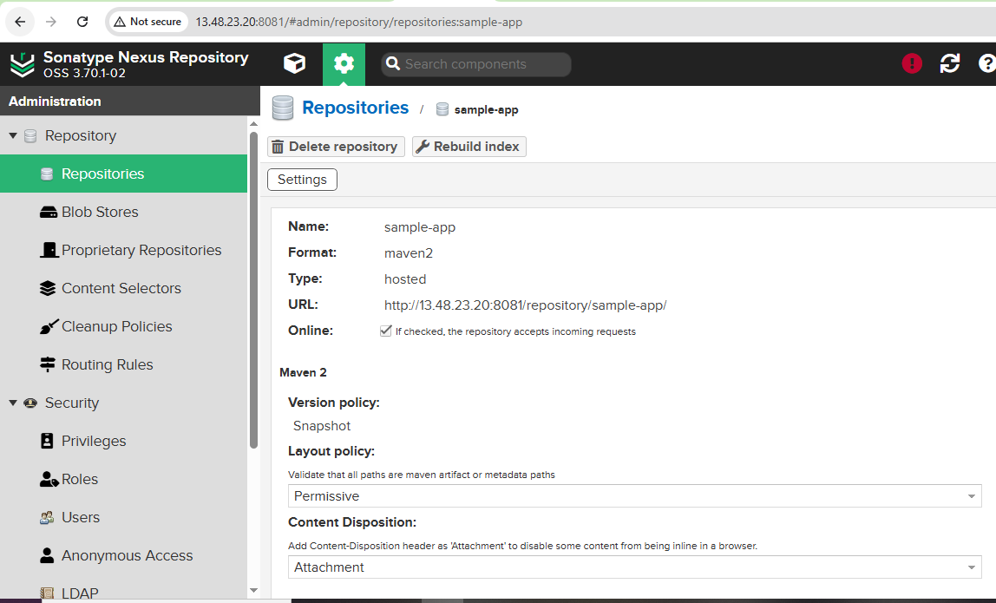
- Slack Notification
- Deploy On tomcat
So the build now worked in the last with the help of above pipeline script:
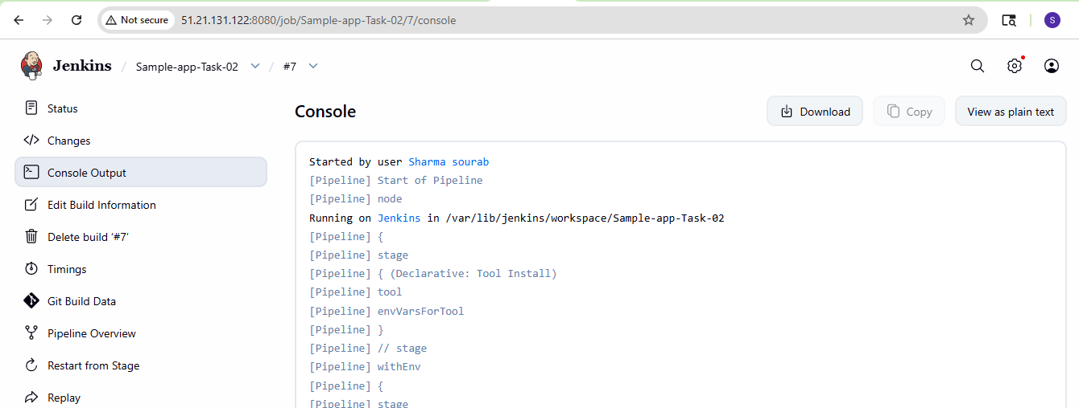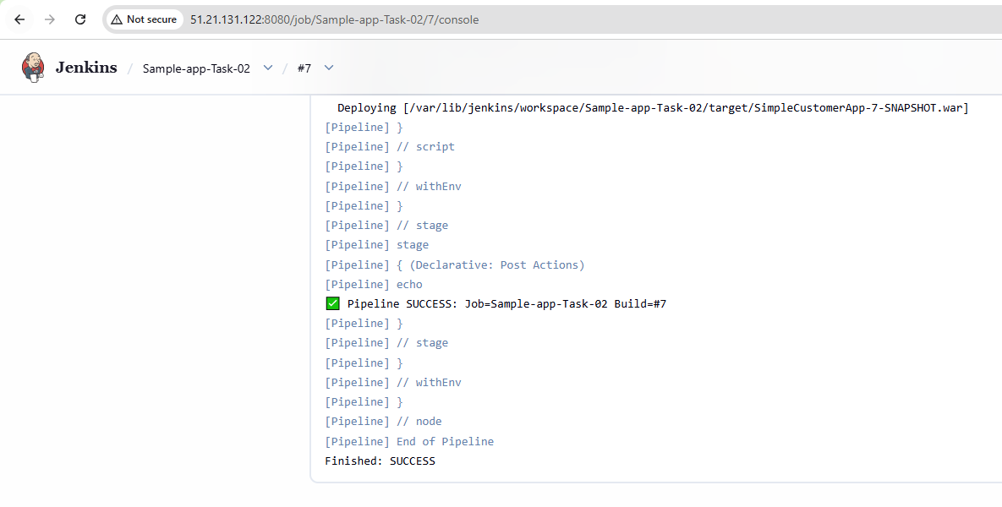
3) Setup a Jenkins CICD pipeline using Scripted pipeline using feature-1.1 branch.
Source Code: https://github.com/betawins/sabear_simplecutomerapp/tree/feature-1.1
stages:
- Git Clone
- SonarQube Integration
- Maven Compilation
- Nexus Artifactory
- Slack Notification
- Deploy On tomcat
Copied the same above {Declarative} script to ChatGPT and then got the scripted pipeline and then pasted the same in the new job which we have been created in Jenkins: node {

- def artifactPath = ""
- def warFile = ""

- stage('Clean Workspace') {

- cleanWs()
- }

- stage('Clone Code') {

- git branch: 'feature-1.1',
- url: 'https://github.com/betawins/sabear_simplecutomerapp.git'
- }

- stage('Build using Maven') {

- def mvnHome = tool 'Maven-home'

- sh """
- ${mvnHome}/bin/mvn clean install
- """
- }

- stage('Check Build Files') {

- sh 'ls -ltr target'
- }

- stage('Publish to Nexus') {

- try {

- artifactPath = sh(
- script: "ls target/*.war | head -1",
- returnStdout: true
- ).trim()

- echo "Uploading Artifact: ${artifactPath}"

- nexusArtifactUploader(

- nexusVersion: 'nexus3',

- protocol: 'http',

- nexusUrl: '13.48.23.20:8081',

- repository: 'sample-app',

- groupId: 'com.javatpoint',

- version: "${BUILD_NUMBER}-SNAPSHOT",

- credentialsId: 'Nexus-task-6000',

- artifacts: [[

- artifactId: 'SimpleCustomerApp',

- classifier: '',

- file: artifactPath,

- type: 'war'

- ]]
- )

- } catch(Exception e) {

- error(
- "Failed to upload artifact to Nexus: ${e.message}"
- )
- }
- }

- stage('Deploy On Tomcat') {

- try {

- warFile = sh(
- script: "ls target/*.war | head -1",
- returnStdout: true
- ).trim()

- echo "Deploying WAR: ${warFile}"

- deploy adapters: [

- tomcat9(

- credentialsId: 'Tomcat-server',

- path: '',

- url: 'http://13.48.148.23:8080'

- )

- ],

- contextPath: '/sabaer',

- war: warFile

- } catch(Exception e) {

- error(
- "Deployment failed: ${e.message}"
- )
- }
- }

- currentBuild.result = "SUCCESS"

- echo """
- Pipeline SUCCESS

- Job: ${JOB_NAME}

- Build: ${BUILD_NUMBER}
- """
- }
Created a new item in Jenkins and then pasted the same scripted pipeline in that:
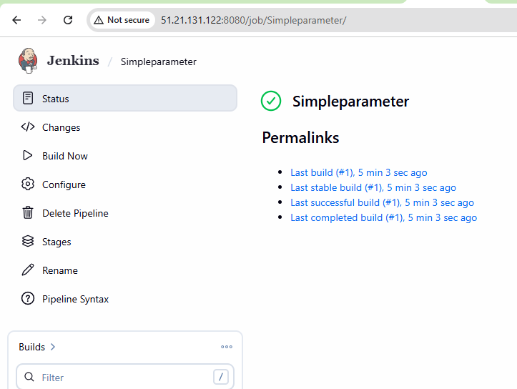
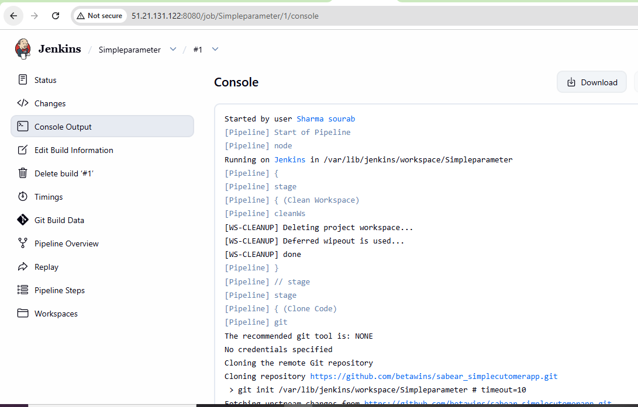 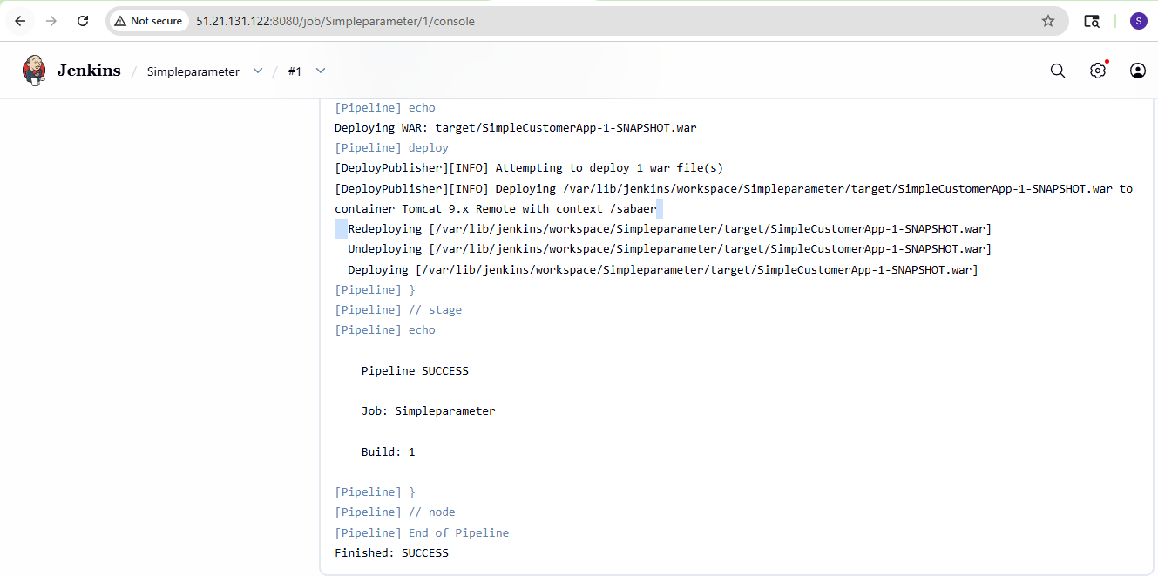
4) Write sample skeleton of pipelines.
pipeline {

agent any

stages {

stage('Build') {

steps {

echo "Building application"

}
}

stage('Test') {

steps {

echo "Running tests"

}
}

stage('Deploy') {

steps {

echo "Deploying application"

}
}
}

post {

success {

echo "Pipeline Success"

}

failure {

echo "Pipeline Failed"

}
}
}
5) Create a parameterized job in Jenkins.
Source Code: https://github.com/betawins/spring3-mvc-maven-xml-hello-world-1.git
Created a new Job in the Jenkins and then clicked the freestyle project and then followed the same steps as follows:
Forked the repo to our repo and then changed the java version from 1.6 to 1.8*.
Follow the below steps as shown:
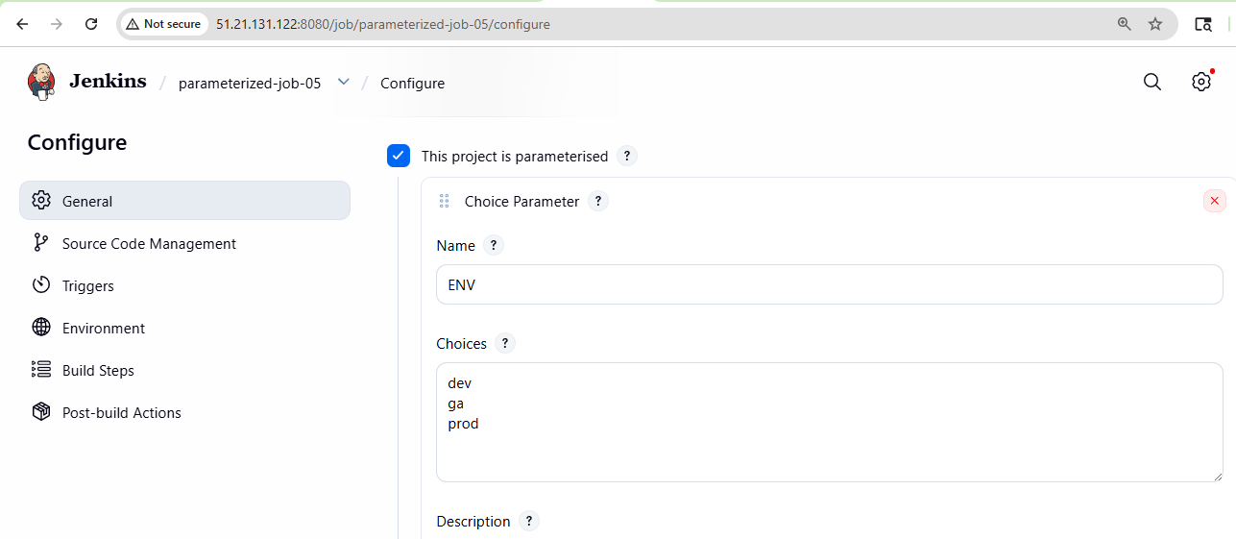 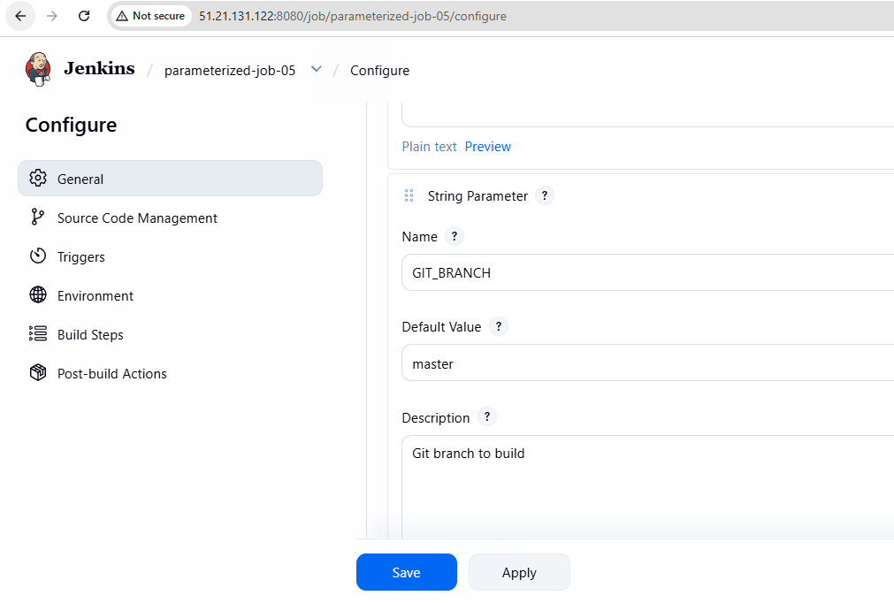 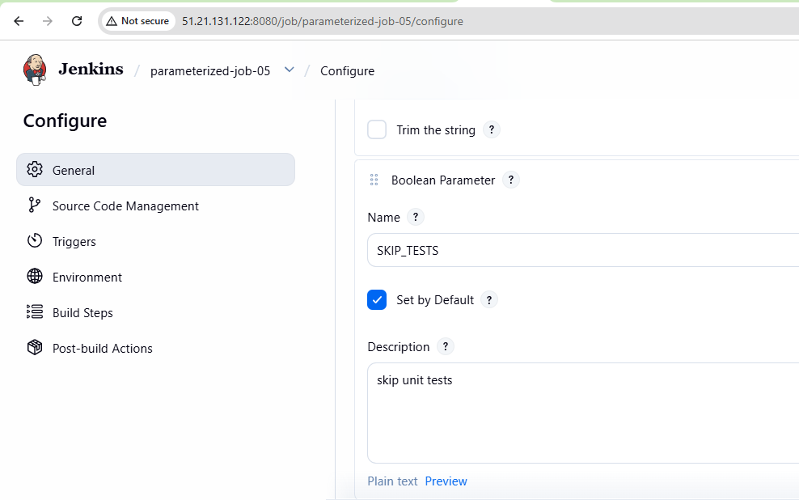 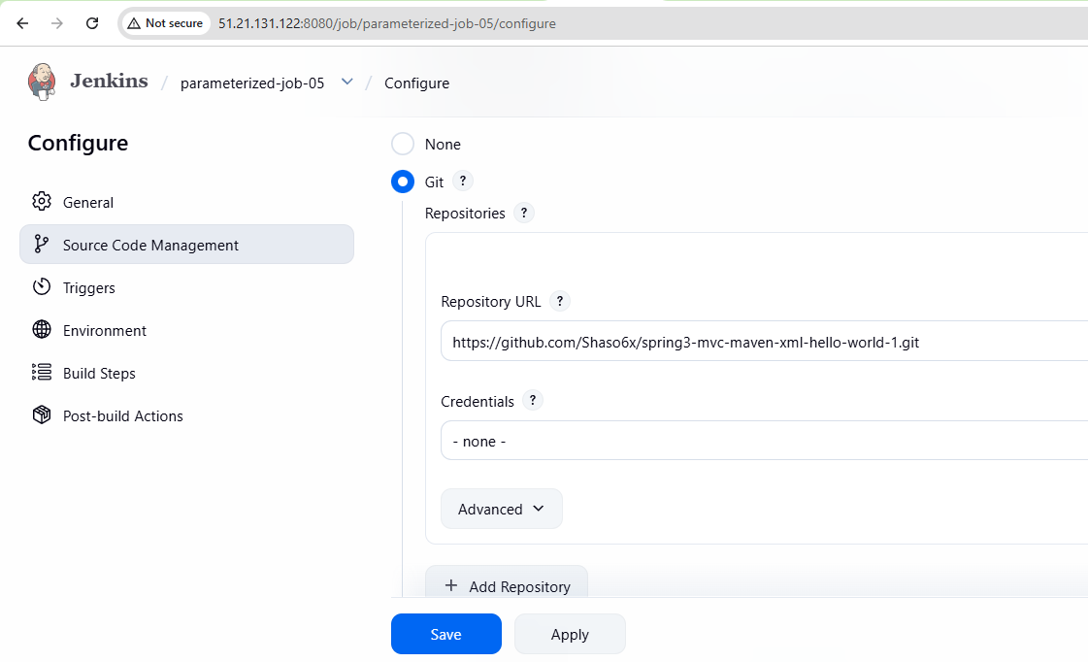 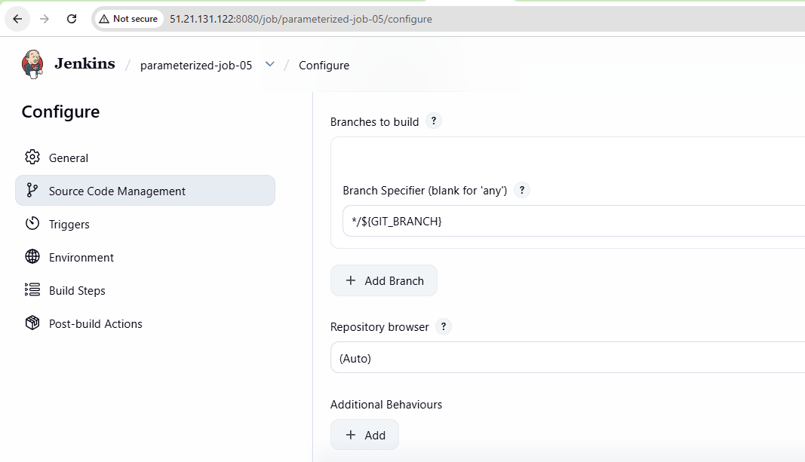 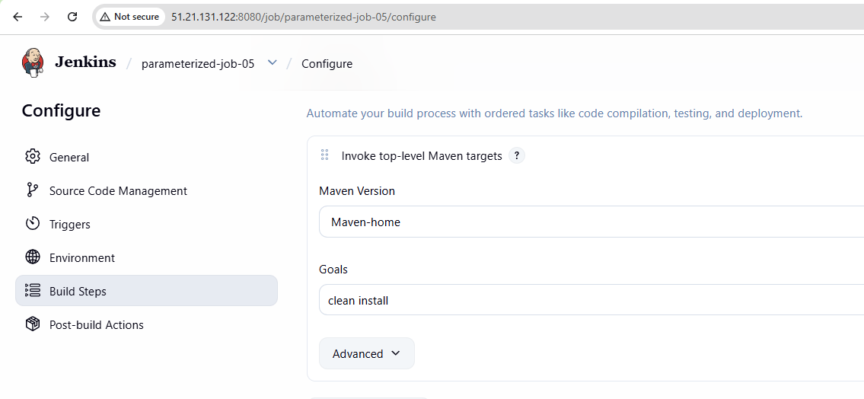
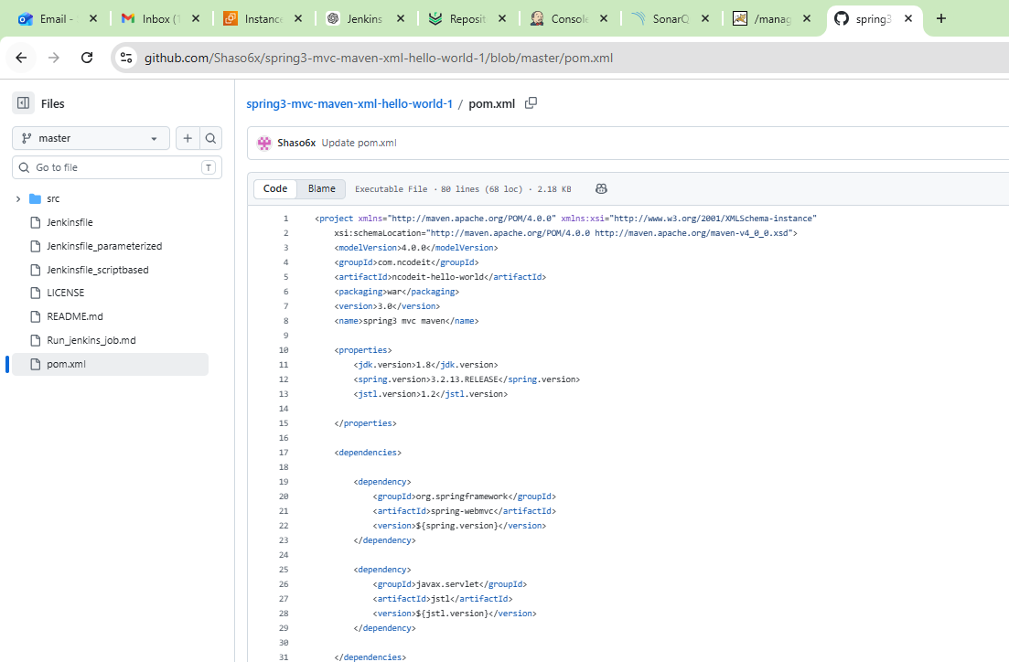
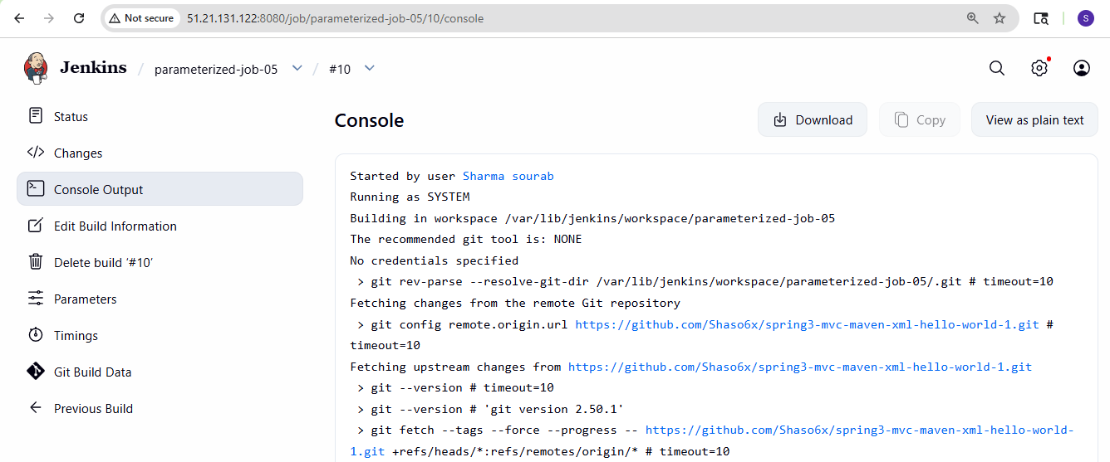 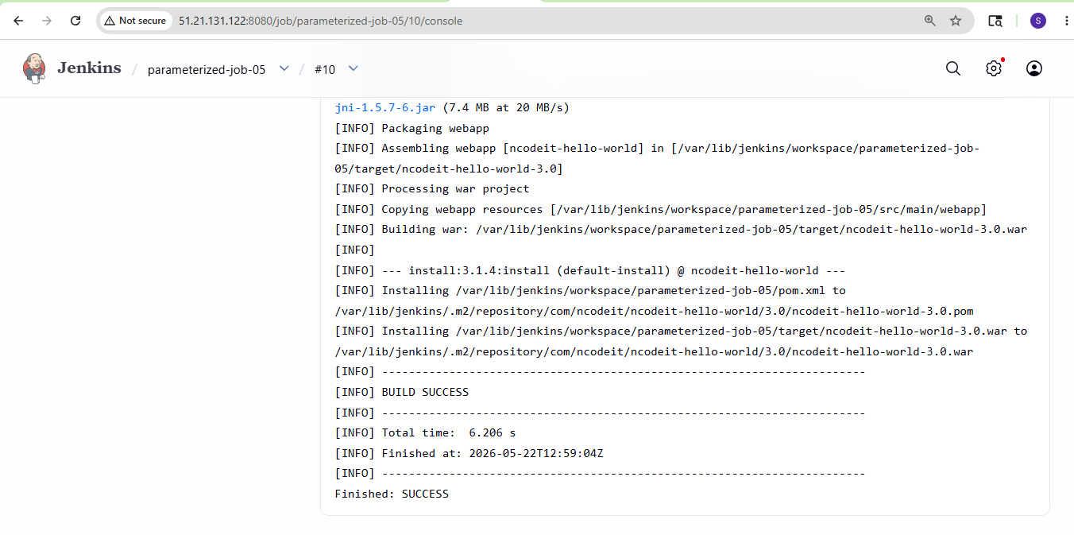
6) Setup one slave machine for Jenkins.
Create .ssh directory for jenkins user
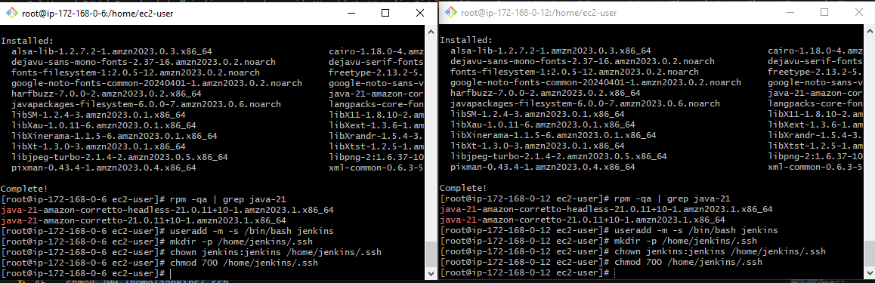
Prepare the Jenkins Controller (Master) – we need to do in Jenkins-
master server
Ensure the 'jenkins' user exists
# The Jenkins RPM package normally creates this user automatically.
# This command checks and creates it only if missing.
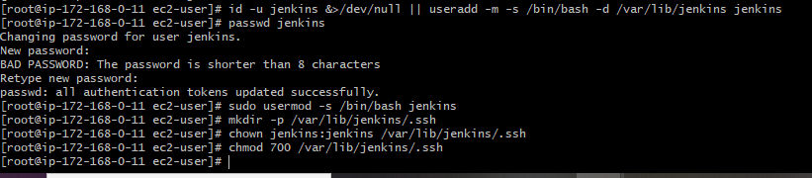
Now switch to Jenkins user → Navigate to .ssh directory
Generate RSA key pair
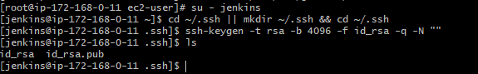
Set correct permissions
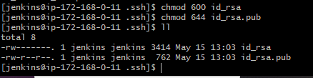
Display the public key (you will need it for slaves) → exit back to root
Public key: `/var/lib/jenkins/.ssh/id_rsa.pub`
Private key: `/var/lib/jenkins/.ssh/id_rsa
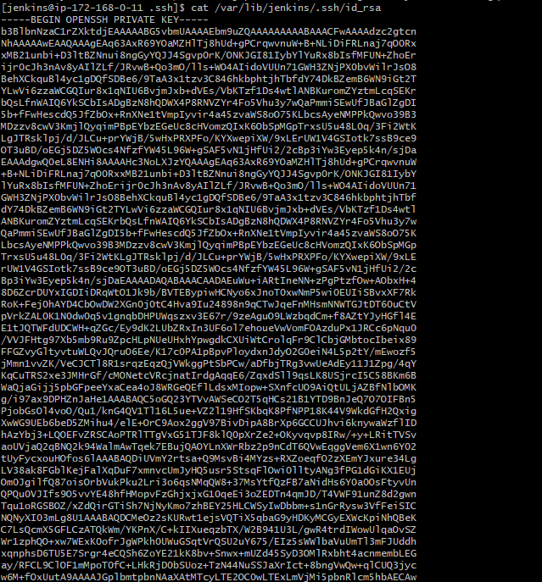
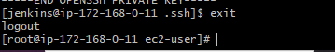
Copy the Public Key to slave Agent
In slave1
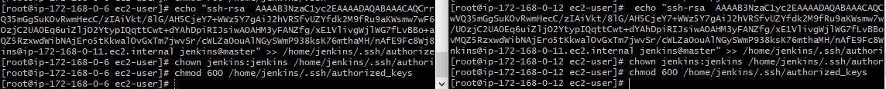
Add Agents' Host Keys to known hosts
Go to Jenkins server
Slave-1
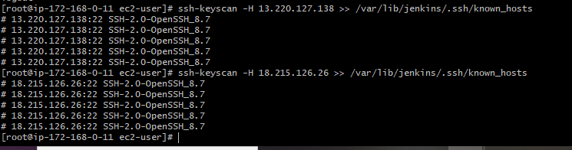
Fix ownership and permissions
Test Password-less SSH Connectivity (From Master to Slave Machines)
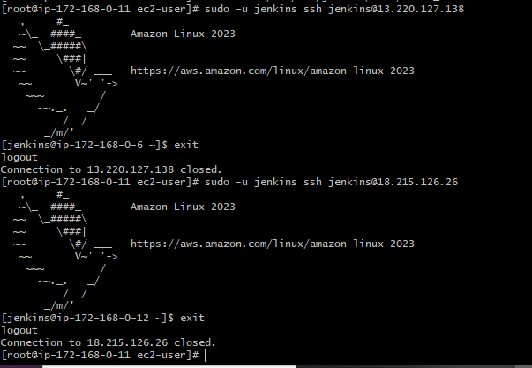
We are able to login to Jenkins
